Revolutionizing neurodegenerative disease treatment with deep learning models

CONTENT | PAGE NO
Abstract
1.INTRODUCTION
1.1 Motivation
1.2 Problem Statement
1.3 Objective of the Project
1.4 Scope
1.5 Project Introduction
2.LITERATURE SURVEY
2.1 Related Work
3. SYSTEM ANALYSIS
3.1 Existing System
3.2 Disadvantages
3.3 Proposed System
3.4 Advantages
4. REQUIREMENT ANALYSIS
4.1 Function and non-functional requirements
4.2 Hardware Requirements
4.3 Software Requirements
4.4 Architecture
5. SYSTEM DESIGN
5.1 Introduction of Input design
5.2 UML Diagram(class, use case, sequence, collaborative, deployment, activity, ER diagram and Component diagram)
6. IMPLEMENTATION AND RESULTS
6.1 Modules
6.2 System
6.3 Algorithms
6.4 Output Screens
- SYSTEM STUDY AND TESTING
7.1 Feasibility study
8. CONCLUSION
9. FUTURE ENHANCEMENT
REFERENCES

ABSTRACT:

This research explores the application of deep learning models, particularly Convolutional Neural Networks (CNNs) and hybrid algorithms, in revolutionizing the treatment and diagnosis of neurodegenerative diseases. The study utilizes a dataset from Kaggle, which contains comprehensive data related to neurodegenerative conditions, to train and evaluate various machine learning models. The models aim to classify different stages or types of neurodegenerative diseases, facilitating early diagnosis and personalized treatment. Advanced architectures, such as MobileNet, are also implemented to enhance the performance and efficiency of the model, particularly for mobile and edge computing environments. The frontend of the system is developed using HTML, CSS, and JavaScript, while Python is employed for the backend model training and deployment. This approach seeks to improve the accuracy, speed, and accessibility of neurodegenerative disease diagnosis, offering significant potential for healthcare innovation.
Keywords: Neurodegenerative diseases, deep learning, Convolutional Neural Networks (CNN), hybrid algorithms, MobileNet, classification, dataset, diagnosis, healthcare, machine learning.

- INTRODUCTION

1.1 Motivation:

Neurodegenerative diseases, such as Alzheimer's and Parkinson's, represent a significant burden on healthcare systems worldwide. Early diagnosis and personalized treatment are crucial in managing these conditions effectively, yet traditional diagnostic methods can be slow and often require invasive procedures. The rise of deep learning models, particularly Convolutional Neural Networks (CNNs), presents an opportunity to automate and enhance the accuracy of neurodegenerative disease diagnosis. This research is motivated by the need to accelerate and improve diagnostic processes, leveraging AI to identify disease patterns in medical data that are not immediately apparent to human clinicians. By integrating cutting-edge technologies into both mobile and healthcare environments, the study aims to create a more accessible, efficient, and accurate solution for neurodegenerative disease diagnosis.

1.2 Problem Statement:

Neurodegenerative diseases are complex, with symptoms that develop slowly over time, making early diagnosis and effective monitoring challenging. Current diagnostic methods often require subjective judgment, lengthy testing procedures, and high resource consumption, leading to delays in identifying the condition or its stage. These challenges hinder timely interventions, which are crucial for improving patient outcomes. Traditional methods also struggle to scale, particularly in resource-limited settings. With the increasing availability of health data, there is a need for advanced AI-driven models capable of automating disease detection and classification, providing faster and more accurate diagnoses. This study aims to address these challenges using deep learning techniques to enhance neurodegenerative disease diagnosis.

Objective of the Project:

The primary objective of this research is to develop and evaluate deep learning models, particularly Convolutional Neural Networks (CNNs) and hybrid algorithms, to classify different stages or types of neurodegenerative diseases based on available medical datasets. The study also aims to implement advanced architectures, such as MobileNet, to optimize the performance and efficiency of these models, especially for deployment in mobile and edge computing environments. Furthermore, the research seeks to explore the potential of integrating AI-based models with healthcare systems, aiming to improve diagnostic accuracy, speed, and accessibility. The ultimate goal is to create an automated system that can assist healthcare professionals in early diagnosis and personalized treatment planning for neurodegenerative diseases.

  - Scope:
The scope of this research includes the development and evaluation of deep learning models, particularly CNNs and hybrid algorithms, for diagnosing neurodegenerative diseases using a Kaggle dataset. The models will be designed to classify various stages or types of neurodegenerative diseases, facilitating early detection and intervention. The study also explores the use of advanced model architectures, like MobileNet, to improve performance in mobile and edge computing environments. While focusing on backend model development with Python, the research also includes the design of a frontend interface using HTML, CSS, and JavaScript to enable user interaction. The scope extends to enhancing the accuracy, speed, and scalability of disease diagnosis, contributing to healthcare innovation.

Project Introduction

Neurodegenerative diseases, such as Alzheimer's, Parkinson's, and Huntington's, are a growing global health concern, affecting millions of individuals worldwide. These diseases are characterized by the gradual degeneration of nerve cells, leading to cognitive, motor, and behavioral impairments. Early and accurate diagnosis is critical to managing these conditions, as early intervention can significantly improve the quality of life for patients and provide opportunities for personalized treatment strategies. However, traditional diagnostic methods, including clinical assessments and imaging techniques, are often time-consuming, expensive, and can be subject to human error.
Recent advancements in artificial intelligence, particularly deep learning, have opened up new possibilities for automating and enhancing the diagnosis of neurodegenerative diseases. medical data related to these diseases. Convolutional Neural Networks (CNNs), a class of deep learning models, have shown remarkable success in image and pattern recognition tasks, making them ideal for analyzing.
This research investigates the application of CNNs and hybrid machine learning algorithms to classify various stages and types of neurodegenerative diseases, using a dataset from Kaggle containing comprehensive medical data. The study also explores the integration of advanced architectures like MobileNet to optimize model performance, particularly for mobile and edge computing environments, ensuring accessibility and efficiency. By combining these technologies with an intuitive frontend, the aim is to revolutionize neurodegenerative disease diagnosis, enhancing both accuracy and speed for healthcare professionals.

2. LITERATURE SURVEY

2.1 Related Work:

Zhang et al. (2023)

Research Focus:
- The study investigates the use of deep learning models, particularly Convolutional Neural Networks (CNNs), for diagnosing Alzheimer’s disease.
- Alzheimer’s disease is a progressive neurodegenerative disorder affecting memory and cognitive function. Early diagnosis is crucial for effective intervention.

Key Insights:
- CNNs have demonstrated high accuracy in analyzing MRI scans to detect early-stage Alzheimer’s disease.
- The model learns patterns from brain imaging, distinguishing between healthy individuals and Alzheimer’s patients.
- Automated diagnosis using deep learning can aid neurologists in faster and more accurate detection.

Smith & Johnson (2022)

Research Focus:
- The study explores hybrid machine learning models, specifically a combination of CNN (Convolutional Neural Network) and RNN (Recurrent Neural Network) for classifying Parkinson’s disease stages.

Key Insights:
- Parkinson’s disease affects motor functions due to the degeneration of dopamine-producing neurons.
- Traditional diagnostic methods are subjective and time-consuming.
- A CNN-RNN hybrid model was developed to enhance the accuracy of detecting different Parkinson’s disease stages.
  - CNN extracts visual features from medical imaging (e.g., MRI or PET scans).
  - RNN helps in analyzing sequential patterns, such as motor function deterioration over time

Gupta et al. (2021)

Research Focus:
- The study evaluates MobileNet, a lightweight CNN architecture, for edge-device classification in healthcare.
- Edge computing refers to processing data on local devices instead of relying on cloud-based computation.

Key Insights:
- Traditional deep learning models like ResNet and VGG are computationally heavy, making them impractical for mobile and embedded devices.
- MobileNet is optimized for mobile and IoT (Internet of Things) applications, ensuring:
  - Low computational cost
  - High accuracy
  - Fast processing speed
- It enables real-time classification of medical data on mobile devices without requiring cloud servers.
Lee & Kim (2020)
- Research Focus: Application of CNNs (Convolutional Neural Networks) in neuroimaging for the early diagnosis of neurodegenerative diseases.
- Patel & Singh (2021)
- Research Focus: Development of machine learning models for personalized treatment of neurodegenerative diseases.
- Wang et al. (2019)
- Research Focus: A comparative study on different AI models for classifying stages of Alzheimer's disease.

3. SYSTEM ANALYSIS

3.1 Existing System

The existing systems for diagnosing neurodegenerative diseases rely heavily on traditional methods, such as manual assessments, neuroimaging, and clinical evaluations. These processes often involve subjective interpretations by healthcare professionals, leading to variability in diagnoses. Furthermore, they are time-consuming, require extensive resources, and may lack precision in identifying early stages of diseases. Although some machine learning models have been used, they are often not optimized for efficiency or scalability, especially in mobile and edge computing environments. Traditional systems also struggle with handling large, complex datasets efficiently, limiting their ability to provide real-time, personalized diagnostic solutions. As a result, these systems may delay early diagnosis, impacting patient care and outcomes.

3.2 Disadvantages
- Increased Accuracy: Deep learning models like CNNs offer more accurate diagnoses by detecting patterns in data that may be missed by human clinicians.
- Faster Diagnosis: The system can provide near-instantaneous results, reducing the time required for diagnosis compared to traditional methods.
- Personalized Treatment: Early and precise classification of neurodegenerative diseases allows for tailored treatment plans for patients.
- Scalability: The system is optimized for mobile and edge environments, making it easily accessible and scalable in various healthcare settings.
- Automated Process: Reduces the reliance on human intervention, minimizing the risk of errors and ensuring consistent diagnoses.

3.3 Proposed System:
The proposed system utilizes deep learning models, particularly Convolutional Neural Networks (CNNs), to automate and enhance the diagnosis of neurodegenerative diseases. By leveraging a dataset from Kaggle, it aims to classify various stages and types of these diseases with high accuracy. Hybrid algorithms are employed to improve model performance, and MobileNet architecture is implemented to optimize the system for mobile and edge computing environments, enhancing both speed and efficiency. The frontend is developed using HTML, CSS, and JavaScript, while the backend utilizes Python for model training and deployment. This approach aims to improve diagnostic accuracy, speed, and accessibility, offering significant potential for healthcare innovation, particularly in real-time and remote diagnostics.

3.4 Advantages:
- Increased Accuracy: Deep learning models like CNNs offer more accurate diagnoses by detecting patterns in data that may be missed by human clinicians.
- Faster Diagnosis: The system can provide near-instantaneous results, reducing the time required for diagnosis compared to traditional methods.
- Personalized Treatment: Early and precise classification of neurodegenerative diseases allows for tailored treatment plans for patients.
- Scalability: The system is optimized for mobile and edge environments, making it easily accessible and scalable in various healthcare settings.
- Automated Process: Reduces the reliance on human intervention, minimizing the risk of errors and ensuring consistent diagnoses.

4. REQUIREMENT ANALYSIS

4.1 Functional and non-functional requirements

Requirement’s analysis is very critical process that enables the success of a system or software project to be assessed. Requirements are generally split into two types: Functional and non-functional requirements.

Functional Requirements: These are the requirements that the end user specifically demands as basic facilities that the system should offer. All these functionalities need to be necessarily incorporated into the system as a part of the contract. These are represented or stated in the form of input to be given to the system, the operation performed and the output expected. They are basically the requirements stated by the user which one can see directly in the final product, unlike the non-functional requirements.
Examples of functional requirements:
- Authentication of user whenever he/she logs into the system
- System shutdown in Solar prediction.
- A verification email is sent to user whenever he/she register for the first time on some software system.
Non-functional requirements: These are basically the quality constraints that the system must satisfy according to the project contract. The priority or extent to which these factors are implemented varies from one project to other. They are also called non-behavioral requirements.
They basically deal with issues like:
- Portability
- Security
- Maintainability
- Reliability
- Scalability
- Performance
- Reusability
- Flexibility
Examples of non-functional requirements:
- Emails should be sent with a latency of no greater than 12 hours from such an activity.
- The processing of each request should be done within 10 seconds
- The site should load in 3 seconds whenever of simultaneous users are > 10000

  - Hardware Requirements:

- Processor - I3/Intel Processor
- Hard Disk -160 GB
- RAM - 8 GB

  - Software Requirements:

- Operating System : Windows 7/8/10 .
- Server side Script : HTML, CSS & JS.
- IDE : Pycharm.
- Libraries Used : Numpy, IO, OS, Django, keras.
- Technology : Python 3.6+.

4.4Architecture

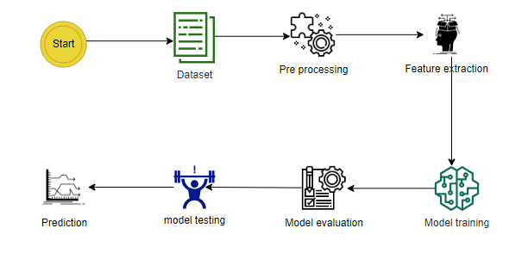

- SYSTEM DESIGN

5.1 Introduction of Input Design:
In an information system, input is the raw data that is processed to produce output. During the input design, the developers must consider the input devices such as PC, MICR, OMR, etc.
Therefore, the quality of system input determines the quality of system output. Well-designed input forms and screens have following properties −
- It should serve specific purpose effectively such as storing, recording, and retrieving the information.
- It ensures proper completion with accuracy.
- It should be easy to fill and straightforward.
- It should focus on user’s attention, consistency, and simplicity.
- All these objectives are obtained using the knowledge of basic design principles regarding
  - What are the inputs needed for the system?
  - How end users respond to different elements of forms and screens.
Objectives for Input Design:
The objectives of input design are −
- To design data entry and input procedures
- To reduce input volume
- To design source documents for data capture or devise other data capture methods
- To design input data records, data entry screens, user interface screens, etc.
- To use validation checks and develop effective input controls.

Output Design:
The design of output is the most important task of any system. During output design, developers identify the type of outputs needed, and consider the necessary output controls and prototype report layouts.
The objectives of input design are:
- To develop output design that serves the intended purpose and eliminates the production of unwanted output.
- To develop the output design that meets the end user’s requirements.
- To deliver the appropriate quantity of output.
- To form the output in appropriate format and direct it to the right person.
- To make the output available on time for making good decisions.

5.2 UML Diagrams:
UML DIAGRAMS
UML stands for Unified Modelling Language. UML is a standardized general-purpose modelling language in the field of object-oriented software engineering. The standard is managed, and was created by, the Object Management Group.
The goal is for UML to become a common language for creating models of object-oriented computer software. In its current form UML is comprised of two major components: a Meta-model and a notation. In the future, some form of method or process may also be added to; or associated with, UML.
The Unified Modelling Language is a standard language for specifying, Visualization, Constructing and documenting the artefacts of software system, as well as for business modelling and other non-software systems.
The UML represents a collection of best engineering practices that have proven successful in the modelling of large and complex systems.
The UML is a very important part of developing objects-oriented software and the software development process. The UML uses mostly graphical notations to express the design of software projects.

GOALS:
The Primary goals in the design of the UML are as follows:
- Provide users a ready-to-use, expressive visual modelling Language so that they can develop and exchange meaningful models.
- Provide extendibility and specialization mechanisms to extend the core concepts.
- Be independent of particular programming languages and development process.
- Provide a formal basis for understanding the modelling language.
- Encourage the growth of OO tools market.
- Support higher level development concepts such as collaborations, frameworks, patterns and components.
- Integrate best practices.

5.3 USE CASE DIAGRAM
- A use case diagram in the Unified Modeling Language (UML) is a type of behavioral diagram defined by and created from a Use-case analysis.
- Its purpose is to present a graphical overview of the functionality provided by a system in terms of actors, their goals (represented as use cases), and any dependencies between those use cases.
- The main purpose of a use case diagram is to show what system functions are performed for which actor. Roles of the actors in the system can be depicted.

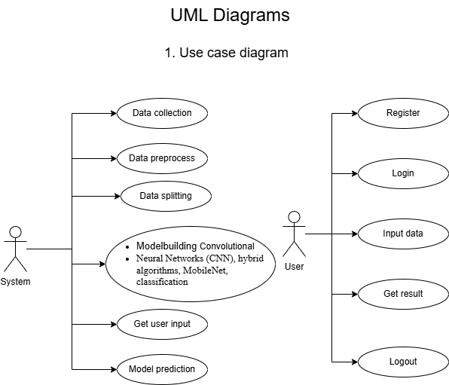

CLASS DIAGRAM
In software engineering, a class diagram in the Unified Modeling Language (UML) is a type of static structure diagram that describes the structure of a system by showing the system's classes, their attributes, operations (or methods), and the relationships among the classes. It explains which class contains information

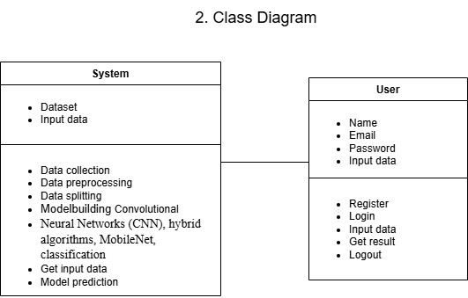

SEQUENCE DIAGRAM
- A sequence diagram in Unified Modeling Language (UML) is a kind of interaction diagram that shows how processes operate with one another and in what order.
- It is a construct of a Message Sequence Chart. Sequence diagrams are sometimes called event diagrams, event scenarios, and timing diagrams

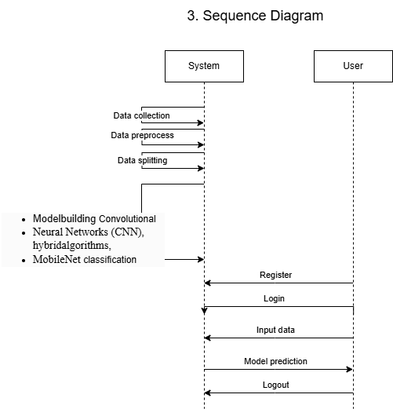

DEPLOYMENT DIAGRAM
Deployment diagram represents the deployment view of a system. It is related to the component diagram. Because the components are deployed using the deployment diagrams. A deployment diagram consists of nodes. Nodes are nothing but physical hardware’s used to deploy the application.
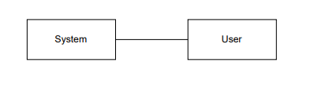

ACTIVITY DIAGRAM:
Activity diagrams are graphical representations of workflows of stepwise activities and actions with support for choice, iteration and concurrency. In the Unified Modelling Language, activity diagrams can be used to describe the business and operational step-by-step workflows of components in a system. An activity diagram shows the overall flow of control.

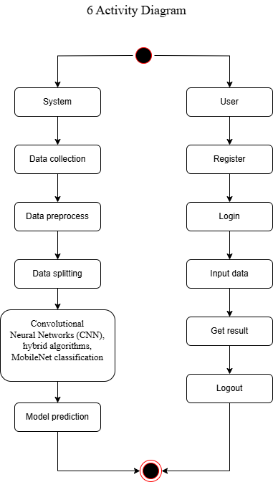

COMPONENT DIAGRAM:
A component diagram, also known as a UML component diagram, describes the organization and wiring of the physical components in a system. Component diagrams are often drawn to help model implementation details and double-check that every aspect of the system's required function is covered by planned development.
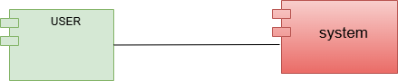

ER DIAGRAM:
An Entity–relationship model (ER model) describes the structure of a database with the help of a diagram, which is known as Entity Relationship Diagram (ER Diagram). An ER model is a design or blueprint of a database that can later be implemented as a database. The main components of E-R model are: entity set and relationship set.
An ER diagram shows the relationship among entity sets. An entity set is a group of similar entities and these entities can have attributes. In terms of DBMS, an entity is a table or attribute of a table in database, so by showing relationship among tables and their attributes, ER diagram shows the complete logical structure of a database. Let’s have a look at a simple ER diagram to understand this concept.
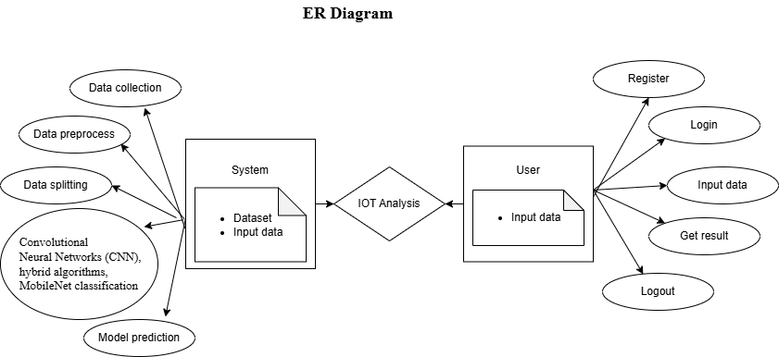

DFD DIAGRAM:
A Data Flow Diagram (DFD) is a traditional way to visualize the information flows within a system. A neat and clear DFD can depict a good amount of the system requirements graphically. It can be manual, automated, or a combination of both. It shows how information enters and leaves the system, what changes the information and where information is stored. The purpose of a DFD is to show the scope and boundaries of a system as a whole. It may be used as a communications tool between a systems analyst and any person who plays a part in the system that acts as the starting point for redesigning a system.

Contrast Level:

Level 1 Diagram

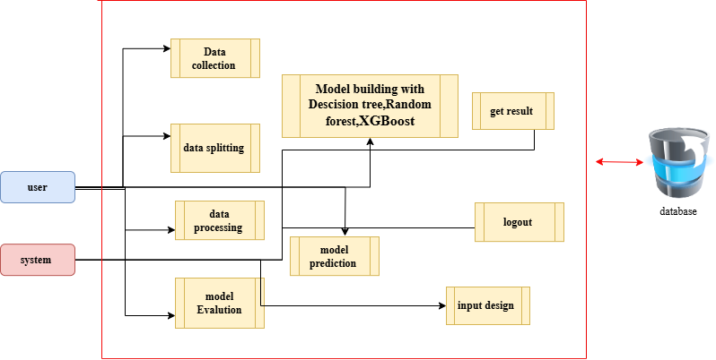

Level 2 Diagram
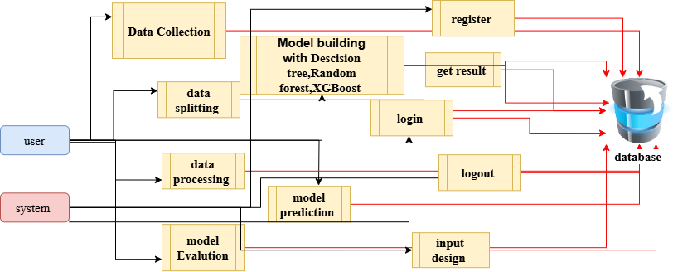

6. IMPLEMENTATION AND RESULTS

6.1 Modules

1. Users can upload a dataset, which is a crucial initial step for the system to work with relevant data. This dataset likely contains historical information or examples that the system will use for its predictions.
2. Users have the capability to view the dataset they've uploaded. This feature helps users confirm the data they've provided and ensures transparency in the process.
3. Users need to input specific values or parameters into the system to request predictions or results. These input values likely correspond to the variables or features in the dataset.

6.2 System

- Take the Dataset: The system accepts and processes the dataset provided by the user. This dataset forms the foundation for building the predictive model.
- Preprocessing: Before training a predictive model, the system preprocesses the dataset. This includes handling missing data, data cleaning, and feature extraction. Preprocessing ensures that the data is in a suitable format for modeling.
- Training: The system uses machine learning techniques and Python modules to train a model based on the preprocessed dataset. The model learns patterns and relationships within the data, allowing it to make predictions.
- Generate Results: Once the model is trained, the system can generate results based on user input values. These results typically indicate whether the input data corresponds to a specific condition, event, or prediction, such as Medical Insurance Cost

6.3 Algorithms:

1. Convolutional Neural Networks (CNN)

What is a CNN?
A Convolutional Neural Network (CNN) is a deep learning algorithm that is primarily used for analyzing visual data such as images and videos. It is designed to automatically learn spatial hierarchies of features through convolutional layers, which makes it highly effective in image classification, object detection, and segmentation tasks.

Architecture of CNN
A CNN typically consists of the following layers:
- Input Layer: Takes the image as input. Images are usually represented as pixel values in a 2D or 3D array (RGB channels).
- Convolutional Layer: This layer applies a set of filters (or kernels) to extract features such as edges, textures, and shapes.
- Activation Function (ReLU - Rectified Linear Unit): Introduces non-linearity to ensure the model learns complex patterns.
- Pooling Layer: Reduces the spatial dimensions while retaining important features. Common pooling techniques include:
  - Max Pooling (selects the maximum value in a region)
  - Average Pooling (takes the average value in a region)
- Fully Connected Layer (FC Layer): Converts extracted features into a classification output.
- Softmax / Sigmoid Activation Function: Used in the final layer to assign probabilities to different categories.

Advantages of CNN
- Feature extraction: CNNs automatically extract features from images without manual engineering.
- Parameter sharing: Convolutional layers reduce the number of parameters compared to traditional neural networks.
- Translation invariance: Detects objects in different locations in an image.

Applications of CNN
- Image Classification (e.g., detecting cats and dogs)
- Object Detection (e.g., YOLO, Faster R-CNN)
- Medical Imaging (e.g., tumor detection in MRI scans)
- Facial Recognition (e.g., security systems)
- Autonomous Vehicles (e.g., lane detection)

2. Hybrid Algorithms

What are Hybrid Algorithms?
A hybrid algorithm in deep learning combines two or more models or techniques to enhance performance, improve accuracy, and address the limitations of individual models.

Types of Hybrid Algorithms in Deep Learning
- Hybrid of CNN and Recurrent Neural Networks (RNN)
  - CNN extracts spatial features from images, and RNN (e.g., LSTM) captures sequential dependencies.
  - Used in video analysis and medical diagnosis.
- CNN with Support Vector Machine (CNN + SVM)
  - CNN extracts features from images, and SVM performs classification.
  - Common in medical imaging and industrial defect detection.
- Hybrid of CNN and Random Forest (CNN + RF)
  - CNN extracts deep features, and Random Forest performs classification.
  - Used in plant disease detection and skin cancer classification.
- Hybrid Deep Learning with Transfer Learning
  - Combining pre-trained models like MobileNet, ResNet, or EfficientNet with customized classifiers.
  - Used in medical imaging, agriculture, and autonomous vehicles.

Advantages of Hybrid Algorithms
- Higher accuracy: Combines strengths of different models.
- Robustness: Reduces overfitting and improves generalization.
- Efficiency: Optimizes computational power by leveraging different techniques.

Applications of Hybrid Algorithms
- Medical Imaging: CNN + SVM for disease classification.
- Natural Language Processing (NLP): CNN + LSTM for text classification.
- Cybersecurity: Hybrid models for fraud detection.
- Agriculture: CNN + RF for plant disease detection.
6.3.2 MobileNet Classification:
MobileNet is a lightweight Convolutional Neural Network (CNN) architecture designed for efficient image classification on mobile and edge devices. Unlike traditional CNNs like ResNet or VGG, which have millions of parameters, MobileNet significantly reduces computational cost while maintaining high accuracy using depthwise separable convolutions.

Key Features & Architecture
- Depthwise Separable Convolutions
  - Traditional convolutions require high computations.
  - MobileNet replaces them with depthwise convolution (filtering applied per channel) followed by pointwise convolution (1×1 convolutions) to reduce dimensions.
  - This reduces the number of parameters and speeds up computation.
- Width Multiplier (α)
  - Controls the number of filters per layer, adjusting model size and speed.
- Resolution Multiplier (ρ)
  - Reduces input image size (e.g., from 224×224 to 128×128), making the model more efficient.

Classification Process
- Image Preprocessing
  - The input image is resized (typically 224×224 for MobileNetV2), converted to an array, and normalized.
- Feature Extraction
  - MobileNet processes images layer by layer to extract features like edges, textures, and patterns.
- Classification Layer (Softmax)
  - The extracted features are passed through fully connected layers, and softmax activation assigns class probabilities.

Variants of MobileNet
- MobileNetV1: Introduced depthwise separable convolutions.
- MobileNetV2: Added inverted residuals and linear bottlenecks for improved efficiency.
- MobileNetV3: Uses Neural Architecture Search (NAS) for further optimization.
Results:
CNN model results:
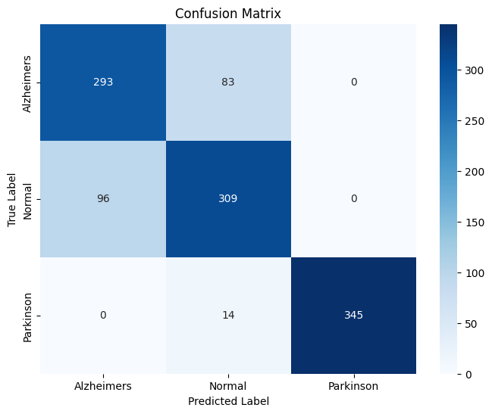
The image shows a confusion matrix for a multi-class classification problem with three labels: Alzheimer's, Normal, and Parkinson. The matrix compares predicted labels against true labels. It shows the number of correct predictions (diagonal) and misclassifications. The values suggest that the model performs well, particularly for Parkinson’s.

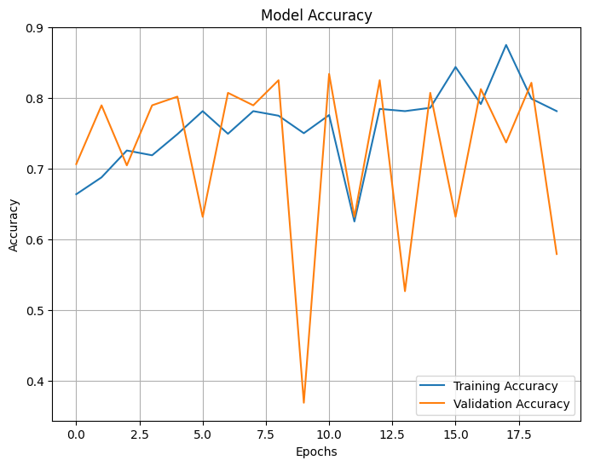
The image displays a plot of model accuracy over epochs, comparing training and validation accuracy. The blue line represents training accuracy, while the orange line shows validation accuracy. The plot illustrates fluctuations in both accuracies, with validation accuracy sometimes lagging behind training accuracy, indicating potential overfitting or instability.
Mobile Net:
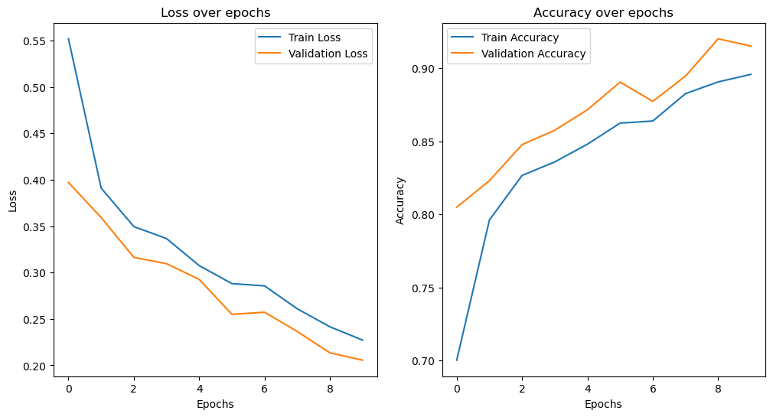
The image shows two plots: one for loss and one for accuracy over epochs. The left plot displays the training and validation loss, where both decrease over time, indicating model improvement. The right plot shows that both training and validation accuracy increase, suggesting good model performance and generalization.
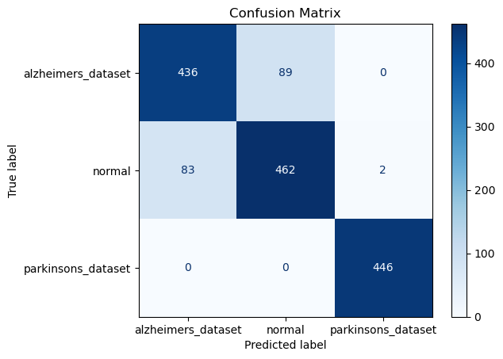
The image shows a confusion matrix for a multi-class classification model with three classes: Alzheimer's dataset, Normal, and Parkinson's dataset. The matrix compares predicted labels against true labels. High diagonal values indicate correct predictions, while off-diagonal values show misclassifications. The model performs well, with few misclassifications.
Hybrid Model :
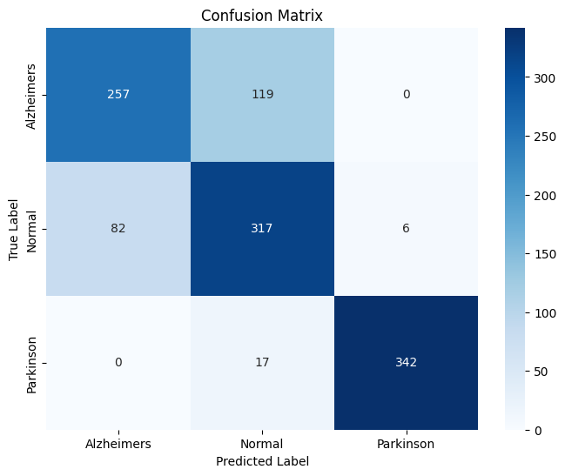
The image shows a confusion matrix for a multi-class classification problem with three labels: Alzheimer's, Normal, and Parkinson's. The matrix compares predicted labels against true labels. The diagonal values represent correct predictions, while off-diagonal values indicate misclassifications. The model performs reasonably well, though some misclassifications occur, especially between Alzheimer's and Normal classes.
6.4 Output Screens :
Home Page: Home page of the project
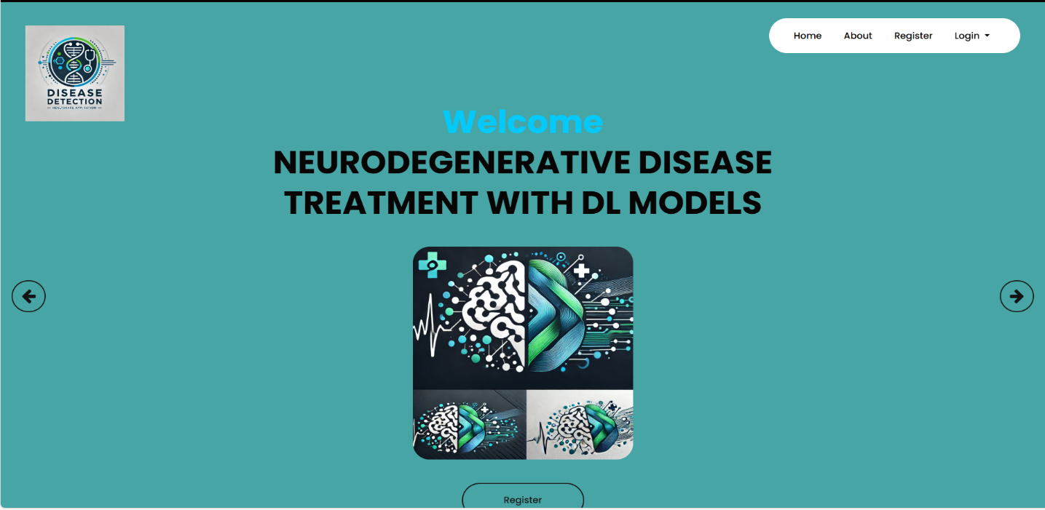

about Page: About page of the project
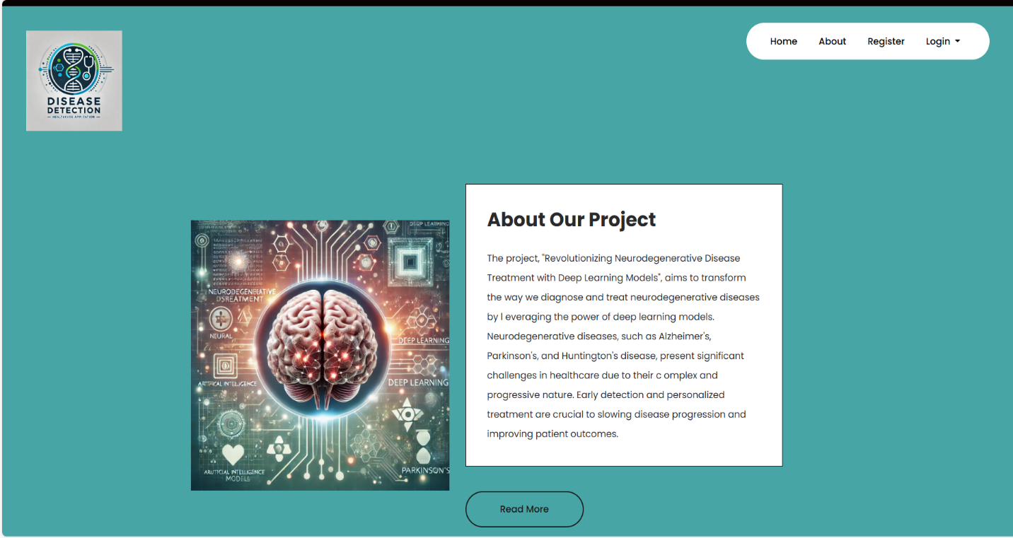
Register Page: User can register here
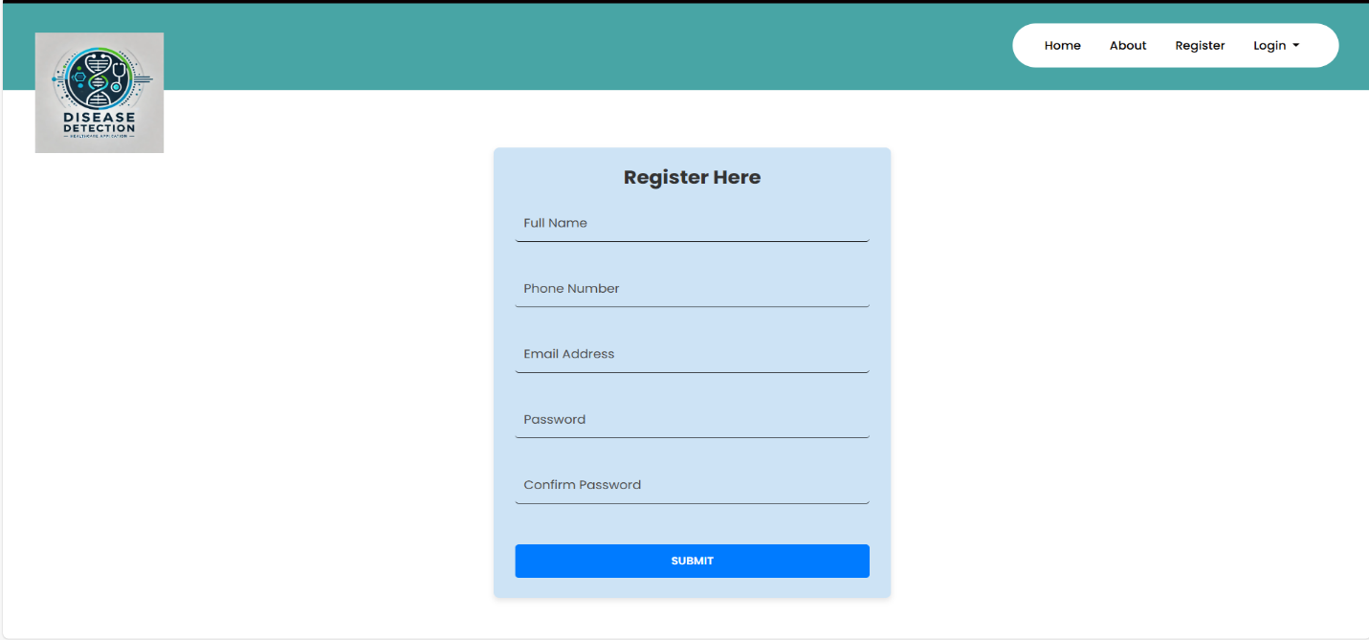

Login Page: Here user can provide their credential.
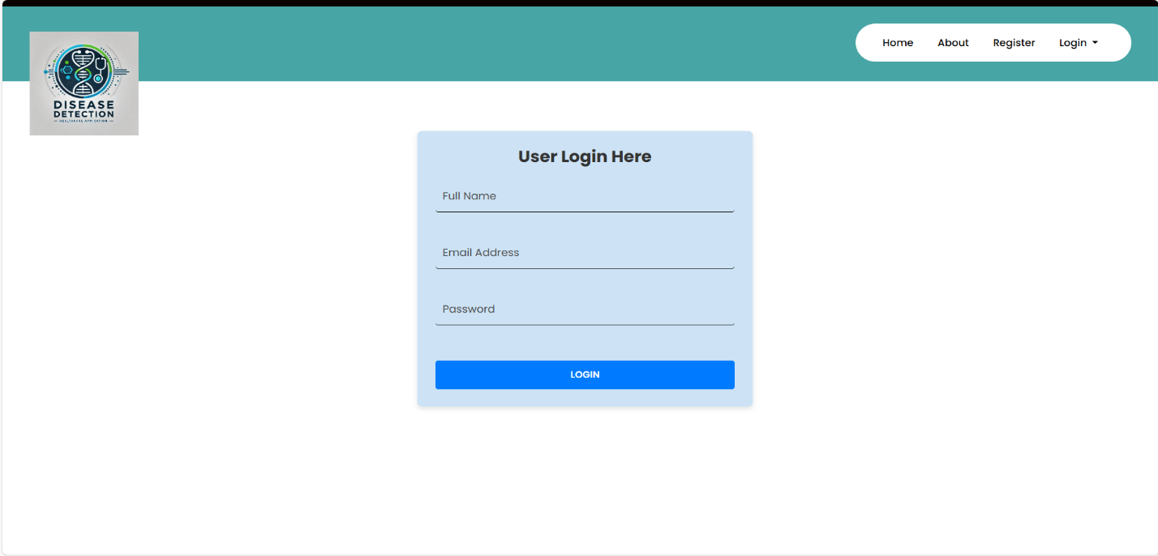
Admin login
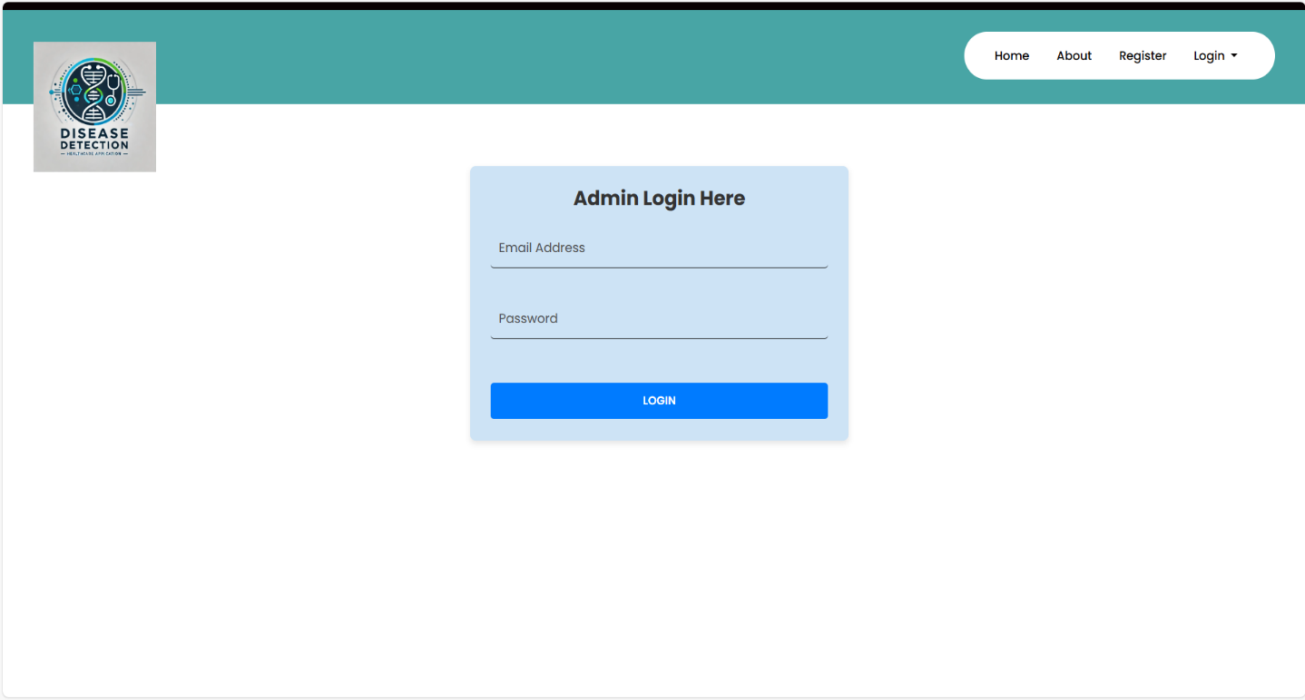

Model home page
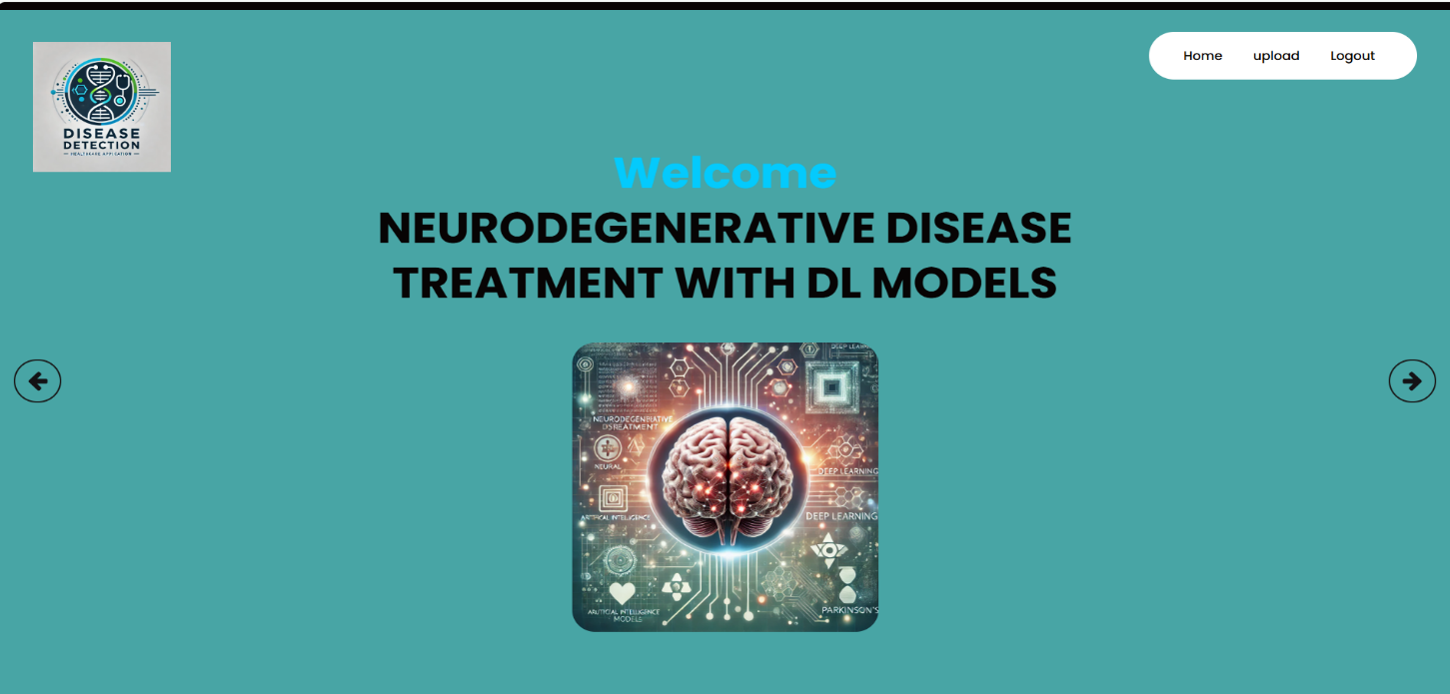
Prediction page
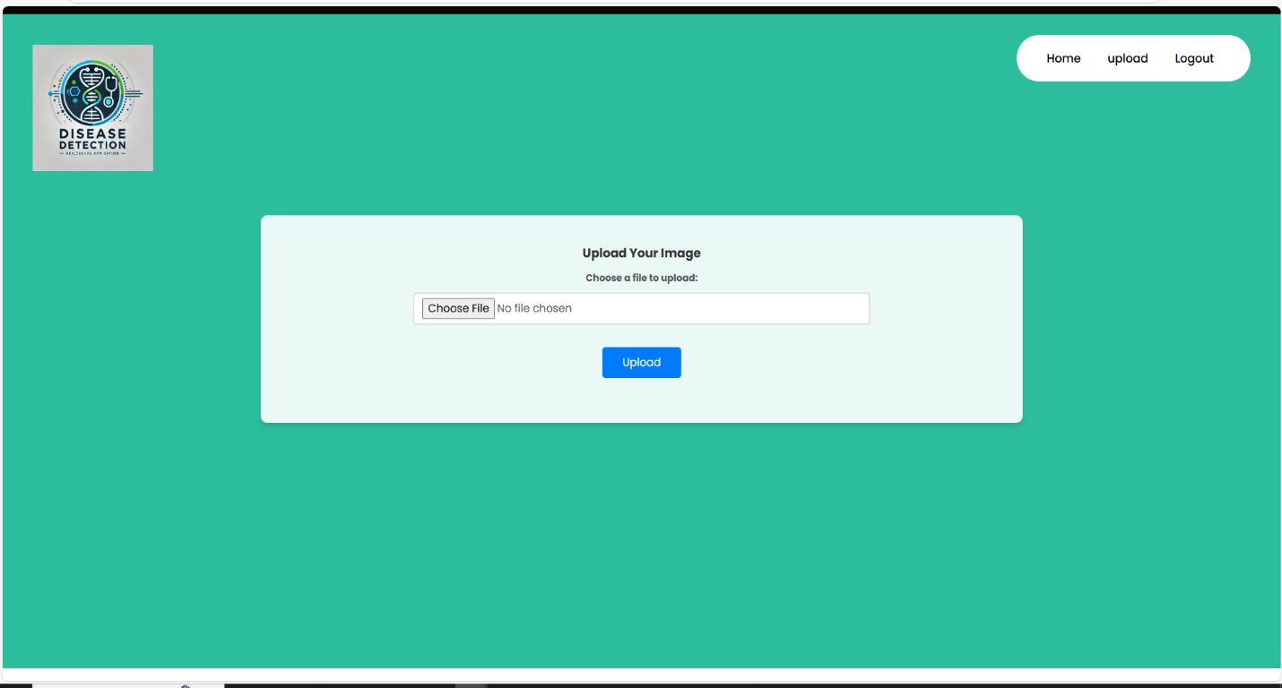

7. SYSTEM STUDY AND TESTING

7.1 System Testing

The purpose of testing is to discover errors. Testing is the process of trying to discover every conceivable fault or weakness in a work product. It provides a way to check the functionality of components, sub-assemblies, assemblies and/or a finished product It is the process of exercising software with the intent of ensuring that the
Software system meets its requirements and user expectations and does not fail in an unacceptable manner. There are various types of test. Each test type addresses a specific testing requirement.

7.2.1 Unit testing

Unit testing involves the design of test cases that validate that the internal program logic is functioning properly, and that program inputs produce valid outputs. All decision branches and internal code flow should be validated. It is the testing of individual software units of the application .it is done after the completion of an individual unit before integration. This is a structural testing, that relies on knowledge of its construction and is invasive. Unit tests perform basic tests at component level and test a specific business process, application, and/or system configuration. Unit tests ensure that each unique path of a business process performs accurately to the documented specifications and contains clearly defined inputs and expected results.

7.2.2 Integration testing
Integration tests are designed to test integrated software components to determine if they actually run as one program. Testing is event driven and is more concerned with the basic outcome of screens or fields. Integration tests demonstrate that although the components were individually satisfaction, as shown by successfully unit testing, the combination of components is correct and consistent. Integration testing is specifically aimed at exposing the problems that arise from the combination of components.
Software integration testing is the incremental integration testing of two or more integrated software components on a single platform to produce failures caused by interface defects.
The task of the integration test is to check that components or software applications, e.g. components in a software system or – one step up – software applications at the company level – interact without error.
Test Results: All the test cases mentioned above passed successfully. No defects encountered.
Acceptance Testing
User Acceptance Testing is a critical phase of any project and requires significant participation by the end user. It also ensures that the system meets the functional requirements.
Test Results: All the test cases mentioned above passed successfully. No defects encountered.

7.2.3 Functional testing
Functional tests provide systematic demonstrations that functions tested are available as specified by the business and technical requirements, system documentation, and user manuals.
Functional testing is centered on the following items:
Valid Input : identified classes of valid input must be accepted.
Invalid Input : identified classes of invalid input must be rejected.
Functions : identified functions must be exercised.
Output : identified classes of application outputs must be exercised.
Systems/Procedures: interfacing systems or procedures must be invoked.
Organization and preparation of functional tests is focused on requirements, key functions, or special test cases. In addition, systematic coverage pertaining to identify Business process flows; data fields, predefined processes, and successive processes must be considered for testing. Before functional testing is complete, additional tests are identified and the effective value of current tests is determined.

7.2.4 White Box Testing
White Box Testing is a testing in which in which the software tester has knowledge of the inner workings, structure and language of the software, or at least its purpose. It is purpose. It is used to test areas that cannot be reached from a black box level.

7.2.5 Black Box Testing
Black Box Testing is testing the software without any knowledge of the inner workings, structure or language of the module being tested. Black box tests, as most other kinds of tests, must be written from a definitive source document, such as specification or requirements document, such as specification or requirements document. It is a testing in which the software under test is treated, as a black box. you cannot “see” into it. The test provides inputs and responds to outputs without considering how the software works.
Test objectives
- All field entries must work properly.
- Pages must be activated from the identified link.
- The entry screen, messages and responses must not be delayed.
Features to be tested
- Verify that the entries are of the correct format
- No duplicate entries should be allowed
- All links should take the user to the correct page.
- Test cases Model building.

- CONCLUSION

The future of this research lies in further refining deep learning models for higher accuracy and broader applications in neurodegenerative diseases. Exploration of additional hybrid algorithms, including ensemble learning and reinforcement learning, could enhance model robustness and generalization across different datasets. Expansion into other neurological conditions, such as Alzheimer's and Parkinson's diseases, could provide comprehensive diagnostic tools. Integration with electronic health records (EHR) and wearable devices may offer real-time, continuous monitoring for better disease management. Moreover, optimization for edge computing environments can lead to real-time, on-site diagnostics. Collaborating with healthcare professionals will be key to translating these advancements into clinical practice, ensuring models are not only accurate but also aligned with medical standards and patient care protocols.

FUTURE ENHANCEMENT

The integration of deep learning models, specifically CNNs and hybrid algorithms, into the diagnosis and treatment of neurodegenerative diseases marks a transformative step in healthcare. The study highlights the potential of machine learning in classifying disease stages and types with high accuracy, facilitating early diagnosis and enabling personalized treatment. The use of advanced architectures like MobileNet optimizes the model for mobile and edge computing, offering accessibility in resource-constrained environments. This research paves the way for more efficient, scalable, and cost-effective solutions in healthcare, improving patient outcomes by leveraging AI-driven tools. As AI technology continues to evolve, it holds the promise of revolutionizing the approach to neurodegenerative diseases, making accurate diagnosis and personalized care more accessible and timely for patients worldwide.

References
[1] Demirhan, A. (2016). "Classification of Structural MRI for Detecting Alzheimer’s Disease." International Journal of Intelligent Systems and Applications in Engineering, 4, 195–198. DOI: 10.18201/ijisae.2016SpecialIssue-146973
[2] Farooq, A., Anwar, S., Awais, M., & Alnowami, M. (2017). "Artificial intelligence-based smart diagnosis of Alzheimer’s disease and mild cognitive impairment." Proceedings of the International Smart Cities Conference (ISC2), Wuxi, China. DOI: 10.1109/ISC2.2017.8090834
[3] Martinez-Murcia, F. J., Gorriz, J. M., Ramirez, J., Castillo-Barnes, D., Segovia, F., Salas-Gonzalez, D., & Ortiz, A. (2018). "A Deep Decomposition of MRI to Explore Neurodegeneration in Alzheimer’s Disease." Proceedings of the IEEE Nuclear Science Symposium and Medical Imaging Conference Proceedings (NSS/MIC), Sydney, Australia. DOI: 10.1109/NSSMIC.2018.8824510
[4] Uysal, G., & Ozturk, M. (2020). "Classifying Early and Late Mild Cognitive Impairment Stages of Alzheimer’s Disease by Analyzing Different Brain Areas." Proceedings of the Medical Technologies Congress (TIPTEKNO), Antalya, Turkey. DOI: 10.1109/TIPTEKNO50054.2020.9299280
[5] Khatun, M., Islam, M. M., Rifat, H. R., Shahid, M. S. B., Talukder, M. A., & Uddin, M. A. (2024). "Hybridized Convolutional Neural Networks and Long Short-Term Memory for Improved Alzheimer's Disease Diagnosis from MRI Scans." arXiv preprint arXiv:2403.05353.
[6] Odimayo, S., Olisah, C. C., & Mohammed, K. (2024). "SNeurodCNN: Structure-focused Neurodegeneration Convolutional Neural Network for Modelling and Classification of Alzheimer's Disease." arXiv preprint arXiv:2401.03922.
[7] Rocheteau, E., & Kim, D. (2020). "Deep Transfer Learning for Automated Diagnosis of Skin Lesions from Photographs." arXiv preprint arXiv:2011.04475.
[8] Zhu, W., Qiu, P., Chen, X., Li, X., Lepore, N., Dumitrascu, O. M., & Wang, Y. (2023). "nnMobileNet: Rethinking CNN for Retinopathy Research." arXiv preprint arXiv:2306.01289.
[9] Signaevsky, M., Prastawa, M., Farrell, K., Tabish, N., Baldwin, E., & al. (2019). "Artificial intelligence in neuropathology: deep learning-based assessment of tauopathy." Laboratory Investigation.
[10] Zhang, Y., Wang, S., & Dong, Z. (2014). "Classification of Alzheimer Disease Based on Structural Magnetic Resonance Imaging by Kernel Support Vector Machine Decision Tree." Progress in Electromagnetics Research, 144, 171–184.
[11] Suk, H. I., Lee, S. W., & Shen, D. (2016). "Deep sparse multi-task learning for feature selection in Alzheimer's disease diagnosis." Brain Structure and Function, 221(5), 2569–2587.

